**Wearable IOT Based Health Prediction System**

**A Report Submitted**

By

**Akanksha Dubey**

**Indian Institute of Information Technology, Dharwad**

**Under the Guidance of**

**Mrs. Payal Saxena**

**Scientist: ‘E’**

**Satellite Communication and Surveillance Group**



*In partial fulfilment of the requirements for the completion of*

**TRAINING**

In

**SUMMER TRAINING PROGRAM**

**DEFENCE ELECTRONICS APPLICATION LABORATORY**

**Defence Research & Development Organization**

**Ministry of Defence, Government of India**

**Dehradun-248001**

**CANDIDATES DECLARATION**

I hereby certify that the work, which is being presented as the report/ project report, entitled **Wearable IOT Based Health Prediction System** partial fulfilment of the requirement for the award of completion certificate of **Summer Training Program,** and submitted to **DEAL** is an authentic record of my own work carried out during the period *19 July 2023* to *31 Aug 2023* under the supervision of Mrs. Payal Saxena.

Akanksha Dubey

Graphic Era Deemed to be University.

Date: 31/08/23

This is to certify that the above statement made by the candidate is correct to the best of my/our knowledge.

Mrs. Payal Saxena

Scientist: ‘E’

DEAL, Dehradun

Date: 31/08/23



**DEFENCE ELECTRONICS APPLICATION LABORATORY**

**Defence Research & Development Organization**

**Ministry of Defence, Government of India**

**Dehradun-248001**

**CERTIFICATE**

This is to certify that Akanksha Dubey, student of Computer Science and Engineering 3rd year, Graphic Era Deemed to be University, Dehradun has successfully completed her project on "**Wearable IOT Based Health Prediction System** " at Wireless Networking division, Defence Electronics Applications Laboratory (DEAL), Dehradun as part of her Industrial Training during July 19, 2023, to Aug 31, 2023. During the training period, she was working under the supervision of Mrs. Payal Saxena, Scientist "E". Her performance during the training was excellent. We wish her all the best for his future.

**Mr. Satyendra Kumar, Sc- “F”**

**Head, WND**

31 Aug 2023

DEAL, Dehradun

**ACKNOWLEDGEMENT**

The satisfaction and euphoria that accompany the successful completion of my project "Wearable IOT Based Health Prediction System" would be incomplete without the mention of the people who made it possible.

First, I would like to extend my special thanks to Mr. Manoj Dhaka (Group Head) and Mr. Satyendra Kumar (Head, WND) for giving me an opportunity to make this project.

I would like to take the opportunity to thank and express sincere gratitude to my project mentor Mrs Payal Saxena. I am greatly indebted to her for providing her valuable guidance and constructive suggestions, I am grateful for her continuous encouragement and positive and supportive attitude without which it would not have been possible to complete the project.

I hope that I can build upon the experience and knowledge that I have gained through this project and make a valuable contribution to my future endeavours.

Akanksha Dubey

Computer Science and Engineering

Graphic Era Deemed to be University.

Dehradun,

Uttarakhand-248002

**ABSTRACT**

The Health Prediction System using wearable device is a project aimed at developing a robust and efficient solution for real-time tracking of health and detecting risk. The system utilizes different sensor data for health tracking, enabling the simultaneous monitoring of users’ health. The user interface is designed to be user-friendly, providing an intuitive graphical user interface (GUI) for users to interact with the system.

The project leverages various technologies and frameworks, including HTML, CSS, JavaScript, and Flask to create a comprehensive web-based application. These webpages are responsible for presenting the health data and risk detection alerts to users in a visually appealing manner. Moreover, the use of sqlite3 for database enhances the system's capabilities for data storage and retrieval.

The health prediction aspect of the system is powered by smartwatch’s sensors , which offers a detailed data about different parameters that are required to track the users’ health. This allows users to monitor the real-time heart rate, spo2 level , and other relevant health related information simultaneously. The integration of sensors facilitates accurate tracking by measuring the values and transmitting data to the system.

Furthermore, the system incorporates risk detection algorithms to identify potential risk to a person based on sensor inputs and based on ‘Nation Early Warning Score’. These algorithms analyse users’ health data in real-time, detecting sudden changes in parameters like heart rate ,spo2 level ,blood pressure and other critical parameters that indicate a risk for person’s health. When a risk is detected, the system promptly alerts the user , allowing them to respond quickly and consult to doctor immediately.

The user-friendly GUI ensures that users can easily access and interpret the tracking and risk detection information. The web-based interface provides interactive graphs for tracking the health record of a user , real-time health updates, and visual indicators for risk alerts.

**TABLE OF CONTENTS**

DECLARATION………………………………………………………………………………

CERTIFICATE………………………………………………………………………………...

ACKNOWLEDGEMENT…………………………………………………………………….

ABSTRACT……………………………………………………………………………………

CHAPTER-1 ORGANIZATION PROFILE

1.1 About DEAL

1.2 IoT Project

1.3 Mission

1.4 Vision

**CHAPTER-2 INTRODUCTION**

2.1 Sensors

2.2 Types of Sensors

2.3 Sensors Used

2.3.1 Accelerometer

            2.3.2 Gyroscope

2.3.3 Optical Heart Rate Sensors

            2.3.4 Oximeter Sensor

            2.3.5 Photoplethysmography Sensor

            2.3.6 Skin Temperature Sensor

2.4 IoT…………………………………………………………………………...

2.5 SATCOM…………………………………………………………………….

2.6 Private-Cloud…………………………………………………………………

2.6.1 Virtual Private Cloud (VPC) …………………………………………

2.6.2 Simple Storage Service (S3) ……………………………………………

2.7 Health Prediction System …………………………………….

CHAPTER-3 OVERALL DESCRIPTION

3.1 Project Perspective

3.2 User Characteristics

3.3 Project Functionality

3.4 System walkthrough

CHAPTER-4 SYSTEM ANALYSIS

4.1 Issue with the current system

4.2 Feasibility Study

3.2.1 Technical Feasibility

3.2.2 Economical Feasibility

3.2.3 Operational Feasibility

4.3 System Requirements

4.3.1 Hardware Specifications

4.3.2 Software Specifications

CHAPTER-5 TOOLS AND TECHNOLOGY

5.1 Python

5.2 Visual Studio Code

CHAPTER-6 CONCLUSION AND FUTURE SCOPE

6.1 Conclusion

6.2 Future Scope

CHAPTER-6 REFERNCE

# CHAPTER 1: ORGANISATION PROFILE

* 1. **About DEAL**

The origin of Defence Electronics Applications Laboratory (DEAL) can be traced back to 1959 when the Defence Research Laboratory (DRL) was set up in the barracks of British Military Hospital at Landour Cannt, Mussoorie as a small field unit of the Defence Science Centre (DSC), Delhi. In those days, DRL was engaged in radio wave propagation studies, food preservation & packaging and study of problems at high altitudes. The reorganization of DRDO in 1962 saw the consolidation of Propagation Studies in the form of Propagation Field Research Station (PFRS), as a field station of DLRL, Hyderabad. On February 23, 1965 PFRS became an independent entity as Himalayan Radio Propagation Unit (HRPU) at Mussoorie with the strength of 84 persons.

HRPU was responsible for helping the Services to set up communication links in the border areas and providing frequency prediction services using data collected from propagation studies. It was also responsible for collecting ionospheric data from its field stations at Jammu & Tejpur. During 1968, HRPU moved to Dehradun and was temporarily located in the old barracks of Instruments Research & Developments Establishment (IRDE). It was renamed as Defence Electronics Applications Laboratory (DEAL) and established in the present location in 1976.

Today DEAL is a major Systems Laboratory of Defence Research & Development Organization (DRDO), pursuing technologies in the front-line areas of satellite-based systems for Communication and Surveillance, software radios, data links, millimetre wave communication, image processing & analysis techniques leading to delivery of fully engineered systems to the Services based on their operational requirements.

* 1. **Satcom Project**

Equipping front-line war-fighters with satellite-based communication solutions, is increasingly becoming an essential part of any military doctrine. Satellite communication provides following advantages that remain unparalleled:

* Distance and location independence
* Reliability
* High availability
* Reconfigurability
* Terrain and remote area communication
* Wide area coverage
* Strategic and tactical applications

In addition to all the above advantages, communication through a mobile platform is also vital for armed forces and SATCOM fits that bill also. It is therefore, no surprise that SATCOM has become a critical element for any military communication network

Keeping in view the world-wide trends, our Armed / Strategic Forces too are increasingly depending on Mobile Satellite Services (MSS), to provide terrain free communication from remote areas. MSS terminals can greatly enhance a war-fighter's capability in mountain and inaccessible areas.

ISRO has enabled Mobile satellite Communication services through the geostationary satellites like GSAT-2, INSAT-3C etc. DEAL has been developing the SATCOM solutions for the armed forces from a long time. This work includes the development and maintenance of various communication devices for the network operation. The HUB architecture includes the number of servers, modems, routers, and gateways supporting the communication.

Sensors are widely deployed in todays’ world which helps network administrators to predict the unwanted situations. Military vehicles are equipped with sensors like accelerometer, gyroscope, etc which can predict the state of vehicle and inform the base station in case of any mishappening.

* 1. **MISSION**

Development of Software based radios, anti-jam data links, secure satellite communication systems, and millimetre wave communication & surveillance systems.

* 1. **VISION**

Be a centre of excellence in the field of military communication & surveillance technologies.

# CHAPTER 2: INTRODUCTION

The purpose of this report is to present a **Wearable IOT based Health Tracking System** designed for users for monitoring their health and analysing the risk based on National Early Warsing Score. The system utilizes advanced **sensors**, including **accelerometers** **gyroscopes**, **optical heart rate sensors** and other smartwatch sensors to track the user’s health and detect health risk to user in real-time. The system's continuous tracking capability, coupled with the ability to detect risk through changes in sensor readings, ensures enhanced situational awareness and timely response for early consultant of doctor to save life.

**2.1 Sensors**

Sensors are devices or components that detect and measure physical quantities or environmental conditions and convert them into electrical signals or other forms of usable data. They are used in various fields such as engineering, science, medicine, automotive industry, and consumer electronics.

**2.2 Types of Sensors**

Health risk systems rely on various sensors to track and evaluate the risk in patients’ health . Here are some types of sensors commonly used in health tracking system :

**2.2.1 Accelerometers**

Accelerometer sensors are the tools that are used to measure the vibration, velocity and acceleration of a body or any object in its instantaneous rest frame. It can track the movement activity such as walking ,step counts, distance travelled, and calories burned.

**2.2.2 Gyroscopes**

Gyroscope sensors are used to measure the rotational motion or angular velocity. It can be used to identify or detect the movement or orientation of the watch during any activity such as running , walking, sleeping etc.

**2.2.3** **Optical Heart Rate Sensor**

It is the sensor that is used to measure the heart rate or pulse rate of a person. It works by using light to detect changes in blood volume in the skin.

**2.2.4** **Oximetry sensors**

Oximetry sensors or SPO2 sensors are used to monitoring the oxygen blood saturation(SPO2)level in a human body. The oxygen saturation level is a vital parameter used in medical settings to assess a person’s circulatory and respiratory health.

**2.2.5** **Bio-Impedance Sensors**

Boi-impedance sensors are devices that is used to measure the electrical resistance or impedance of biological tissues to the flow of a weak electric current. These sensors are basically used in medical and health monitoring applications to obtain valuable information about person’s body composition, hydration status and other parameters.

**2.2.6** **GPS sensors**

Global Positioning System (GPS) sensors can be used to track the location and for navigation.

**2.2.7 Skin Temperature Sensors**

Skin temperature sensors are used to detect changes in human body temperature which can be useful for monitoring overall health and wellness.

**2.3 Sensors Used**

**2.3.1 Accelerometer**

An accelerometer is a sensor commonly used in health systems. It measures changes in acceleration, and vibration experienced by a body. The working principle of an accelerometer involves the use of piezoelectric or MEMS technology. These sensors work based on capacitance and are designed to measure the force of acceleration on a mass within the sensor structure.

In health monitoring systems, accelerometers play a critical role in identifying sudden change in body movement and vibration or impact events. They can sense the rapid changes in acceleration associated with body and trigger appropriate actions or alerts. The accelerometer sensors continuously measure acceleration forces acting on the device i.e., smartwatch in different direction (along three axes: X,Y, and Z).These data is used to identify the body movement during an activity and its impact on other health parameters.

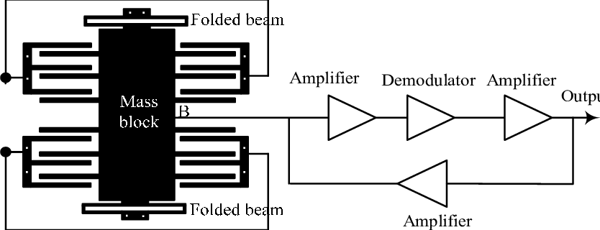

Fig: MEMS Accelerometer

Accelerometer sensor data is usually represented in units of acceleration, such as meters per second squared (m/s²) or gravitational units (g) and they are typically provided with specific sampling rate (here 100 Hz).

Below is the snippet of data received from Accelerometer.

**2.3.2 Gyroscope**

Gyroscopes are utilized in health tracking and risk detection systems to provide information about the physical activity, motion, and posture. A gyroscope measures angular velocity or rotational motion. It can help in fall detection, stress and fatigue monitoring.

Gyroscopes can complement accelerometers by offering insights into the rotational forces acting on the body during any fall or sudden changes in posture. By combining the data from accelerometers and gyroscopes, health monitor system can provide a more comprehensive analysis of the physical activity and its impact on other health parameters .Gyroscopes can be based on MEMS or fibre-optic technology. They provide advantages such as precise measurement of rotational motion and responsiveness to changes in orientation.

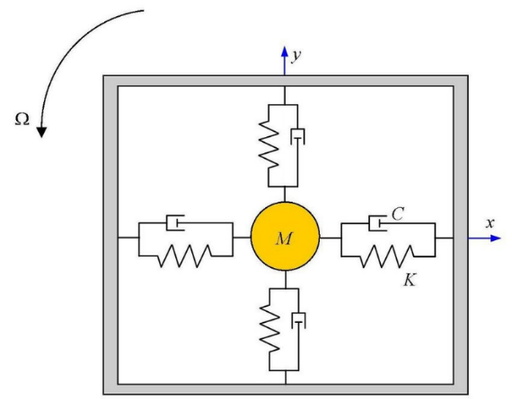

Fig: Gyroscope

The data provided by a gyroscope sensor typically includes three axes: X, Y, and Z, representing the rotation around each respective axis.The gyroscope sensor data is typically represented in units of angular velocity, such as degrees per second (°/s) or radians per second (rad/s). The data is often provided as a set of three values, one for each axis, indicating the rotation rate around that axis at a given moment.

The gyroscope sensor data is typically provided at a specific sampling rate, indicating how frequently the sensor updates and provides new data. The sampling rate is usually measured in Hertz (Hz), indicating the number of times per second the sensor captures and reports the rotation data. Here sampling Rate is 100Hz.

Below is the sample snippet of data received:

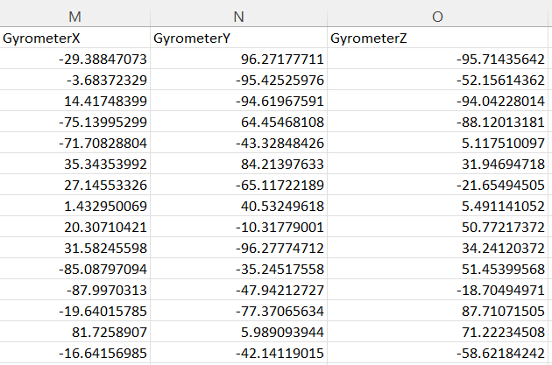

**2.3.3 Optical Heart Rate Sensor**

Optical Heart Rate sensors is used to measures the heart rate and pulse waves. It works by using light to detect changes in blood volume in the skin. These sensors in the smartwatches measures the pulse rate by scanning blood flow near wrist by irradiating it with LEDs. The green light is used because it absorbs well by our red blood, so the sensors can estimate the blood flow and heartbeat more accurately.

In our system along with readings of accelerometer and gyrometer and heart rate readings it will be able to predict the heart risk in a person. Readings of accelerometer and gyrometer will help in predicting the type of physical activity and heart rate sensors will measure the heart rate during the activity.

Below is the data received from Optical Heart Rate Sensor

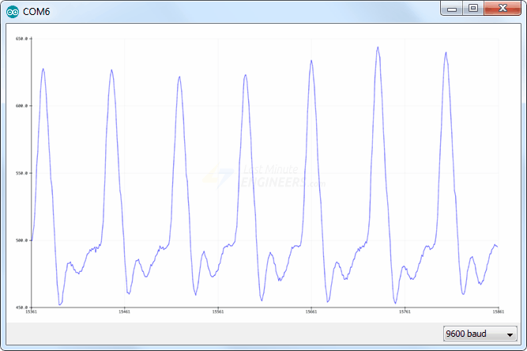

Fig: Raw Data of Optical Heart Rate Sensor

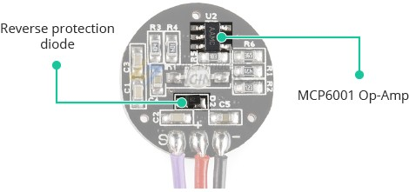

Fig: Optical Heart Rate Sensor

**2.3.4 Oximetry Sensor**

Oximetry sensors in smartwatches commonly known as pulse oximeters are specifically designed to measure the oxygen saturation level in your blood termed as SpO2(peripheral capillary oxygen saturation).

The sensor emotes specified wavelength of light of two types red and infrared because they are absorbed by deoxygenated and oxygenated haemoglobin in blood differently. The photodetector measures the amount of infrared and red light that is reaches it after passing through blood vessels. By comparing the amount of these two-light absorbed by blood the sensors algorithm calculates the ratio of oxygenated haemoglobin to total haemoglobin. This ratio is converted into a percentage, which represents blood oxygen saturation level (Spo2).

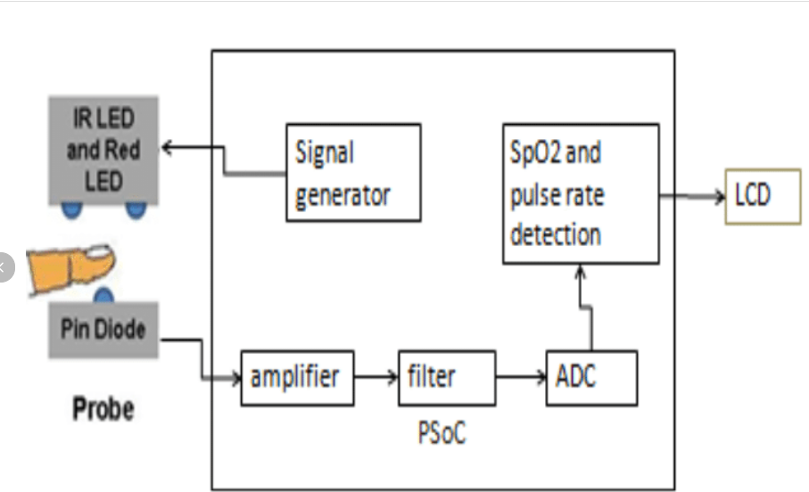

Fig: Working of Oximeter Sensor

In health tracking system the oximeter sensor data is used to measure and analyse the spO2 level of a person .The threshold of determining the safe level of spO2 is set based on Nation Early Waring Score.

**2.3.5 Photoplethysmography Sensor**

Photoplethysmography sensors are an optically obtained plethysmogram to track and monitor blood volume change in the body. It consists of two components : light emitting diode(LEDs) and photodetector(PDs). LED lights red and infrared are used to measure the blood flow in the body and PDs is used to detect the volumetric change in the blood from cardiac pressure by absorbing the light through skin from LEDs.

In our system this sensor data from smartwatch is used to monitor and analyse the blood pressure level in a body.

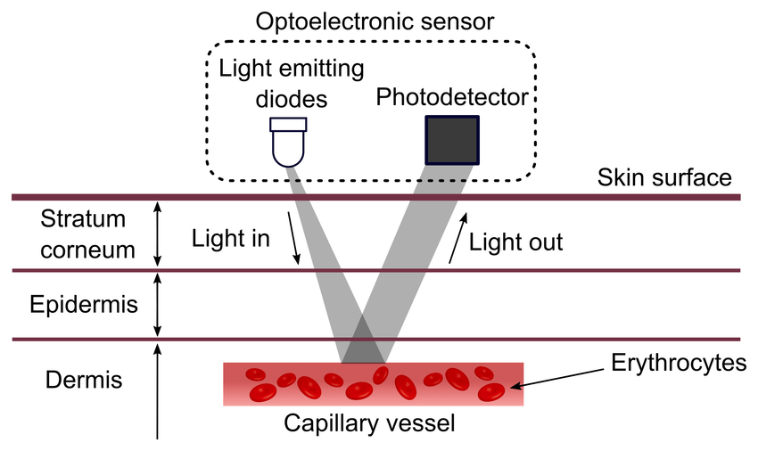

Fig: Working of Photoplethysmography Sensor

**2.3.6 Skin Temperature Sensor**

Health tracking system uses the skin temperature sensor’s data to measure the amount of heat is dissipating from a body after exercise or workout. It is used to monitor the increase in body temperature.

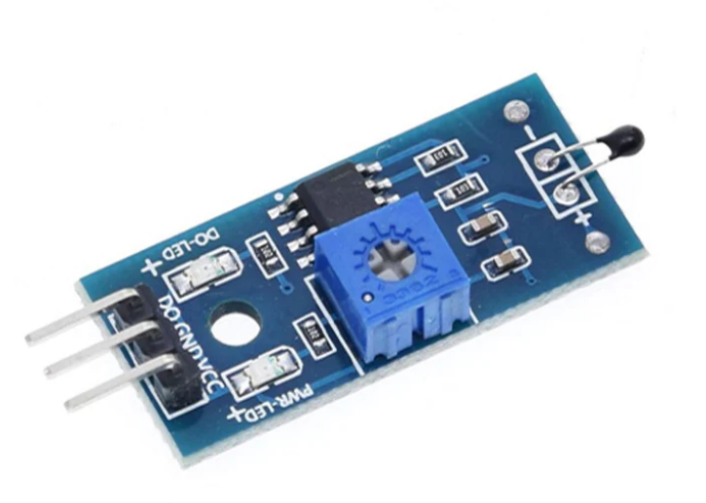

Fig: Temperature Sensor

**2.4 IoT Device**

In this system, an Internet of Things (IoT) device smartwatch equipped with accelerometers, gyroscopes, and other sensors has been used to measure and collect the data of different parameters for our system for health tracking and risk prediction. The accelerometer and gyroscope readings provide valuable information about changes in acceleration and orientation, allowing the system to detect change in the body ,posture analysis and its impact on other parameters . Simultaneously, the other sensor provides precise health parameters values facilitating accurate health tracking.The integration of IoT devices, satellite communication, cloud infrastructure, and web-based user interfaces offers a comprehensive solution for efficient tracking and risk detection, empowering healthcare system to monitor and respond to health risk promptly and early medications are given to the user.

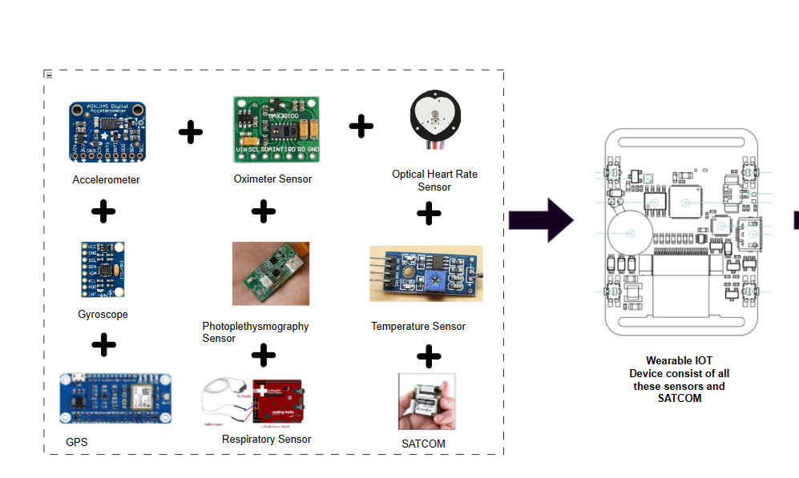

Fig: IoT Device

Accelerometer , gyroscope optical heart rate sensor, oximeter, temperature sensor and bio impedance sensors along with GPS constitute the IoT Device which will then be attached to our wearable device. These sensors are getting its power from wearable device i.e., smartwatch.

**2.5 SATCOM Connection**

The IoT device sends the collected sensor data to a Low Earth Orbit (LEO) satellite via the SATCOM connection. The LEO satellite acts as a relay, transmitting the data to health centres on Earth.

This data is transmitted via the **L-Band** frequency range to a Low Earth Orbit (LEO) satellite. The L-Band spectrum, operating at 1 to 2 GHz, offers excellent signal penetration capabilities, making it suitable for communication in challenging environments such as establishing the communication at rural areas . Furthermore, L-Band frequencies are globally allocated for satellite communication services, ensuring reliable and uninterrupted connectivity on a worldwide scale.

By leveraging the L-Band, our health tracking and risk detection system can efficiently transmit sensor data to the LEO satellite, enabling swift and efficient incident response and providing critical information for emergency services to the nearby healthcare centres.

The use of compact L-Band antennas and equipment further enhances the system's portability and ease of deployment. Overall, the integration of L-Band communication in our IoT-based health tracking and risk system enhances its reliability, coverage, and ability to deliver real-time patient data for prompt and effective emergency assistance.

Below is the image of LEO satellite module which will connect our IoT device to our LEO satellite.

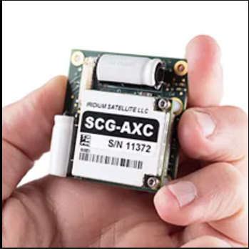

Fig: Satellite IoT Module

There are many alternative available for this. We can use any one of these.

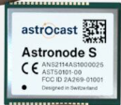 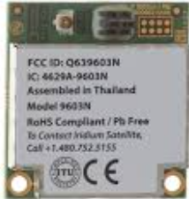

Fig: Alernatives

**2.5.1 LEO Satellite**

LEO stands for Low Earth Orbit, and a LEO satellite refers to a type of satellite that operates in this specific orbit. LEO satellites are positioned in a relatively low orbit around the Earth, typically at altitudes ranging from a few hundred kilometres to around 2,000 kilometres. Unlike satellites in higher orbits, LEO satellites are closer to the Earth's surface.

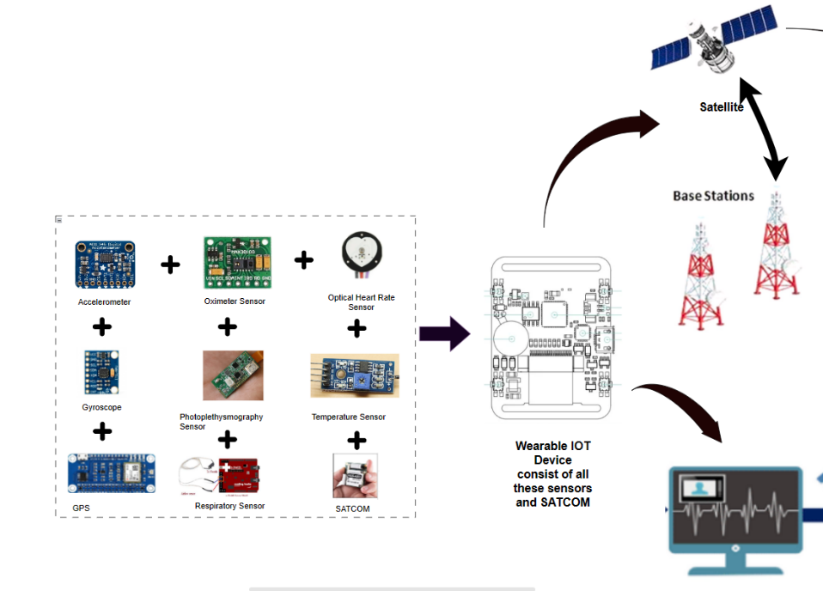

Fig: Flow of Data from IoT device to Base Station

**2.6 Private Cloud**

From these centres, the data is redirected to a private cloud infrastructure hosted on AWS. The private cloud serves as a secure and scalable storage solution, ensuring the efficient handling of the incoming sensor data.



**2.6.1** **Virtual Private Cloud (VPC)**

**VPC (Virtual Private Cloud)** is a virtual network infrastructure provided by Amazon Web Services (AWS). It enables users to create isolated virtual networks within the AWS cloud environment. With VPC, users can define their own private IP address range, subnets, and network configurations, giving them control over their virtual network environment.

Features of VPC: -

1. Isolation: VPC allows users to create isolated virtual networks, providing enhanced security and isolation for their resources and data. It enables users to define their own network settings and access controls.
2. Customization: Users have the flexibility to define their IP address range, subnets, and routing tables within their VPC. This allows for customized network configurations based on specific requirements and organizational needs.
3. Security: VPC incorporates various security features, including network access control lists (ACLs) and security groups, to control inbound and outbound traffic at the network and instance level. This helps in securing the resources within the VPC.
4. Scalability: VPC is designed to be highly scalable, allowing users to easily scale their network resources up or down as needed. This ensures that the virtual network can accommodate changing demands and resource requirements.
5. Integration with Other AWS Services: VPC seamlessly integrates with other AWS services, such as EC2 (Elastic Compute Cloud) instances, RDS (Relational Database Service), and Lambda functions, enabling users to deploy and manage their resources securely within their VPC environment.

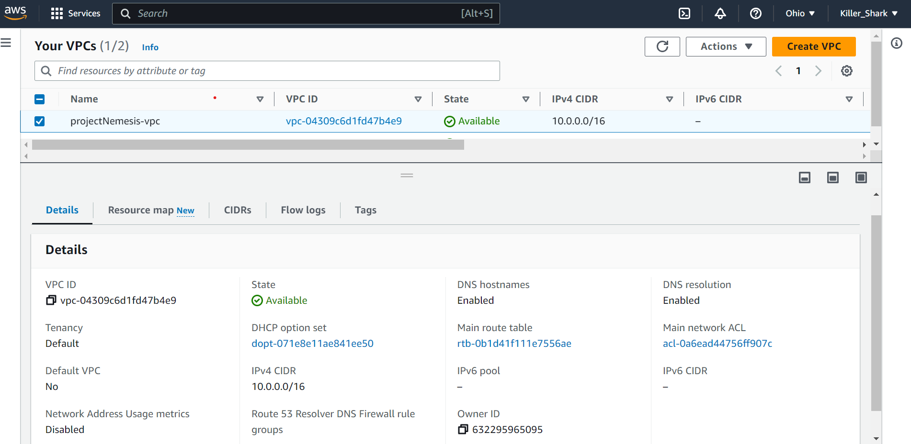

Fig: Virtual Private Cloud (AWS VPC)

**2.6.2 Simple Storage System (S3)**

Amazon S3 (Simple Storage Service) is a highly scalable and durable cloud storage service provided by Amazon Web Services (AWS). It offers secure, reliable, and cost-effective storage for storing and retrieving data from anywhere on the web.

Functions of S3: -

1. Scalability: S3 is designed to be highly scalable, allowing users to store and retrieve any amount of data seamlessly. It can handle massive workloads and accommodate growing storage requirements without any disruption.
2. Durability and Reliability: S3 provides high durability, meaning that it is designed to protect against the loss of data. It achieves this through redundant storage across multiple devices and facilities, ensuring that data remains available even in the event of hardware failures.
3. Accessibility and Availability: Data stored in S3 is accessible from anywhere on the web. It offers high availability, allowing users to retrieve their data quickly whenever needed. S3 also provides features like data versioning and multi-region replication for increased data availability and protection.
4. Security: S3 incorporates robust security features to protect stored data. It provides access control mechanisms through bucket policies and Access Control Lists (ACLs). Encryption options are available to ensure data privacy, including server-side encryption and client-side encryption.
5. Data Management and Lifecycle Policies: S3 allows users to manage their data effectively through lifecycle policies. These policies enable automatic transitioning of data between storage classes based on predefined rules, optimizing cost and performance.
6. Integration with Other AWS Services: S3 integrates seamlessly with other AWS services, making it easy to incorporate storage functionality into various applications and workflows. It can be used as a storage solution for applications, as a backup and restore service, or as a data source for data analytics and processing services.

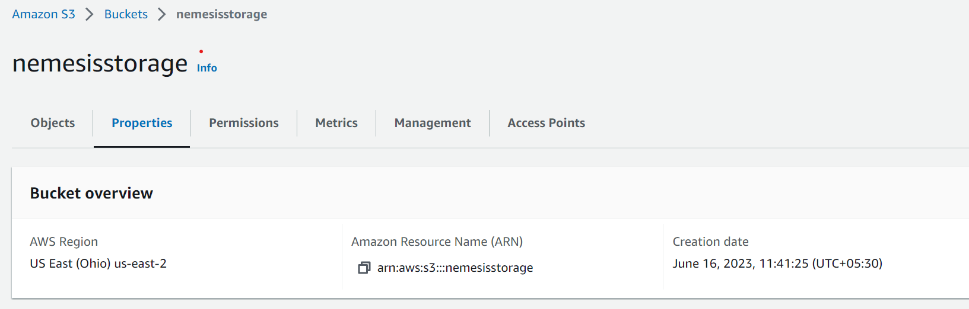

Fig: S3 Storage

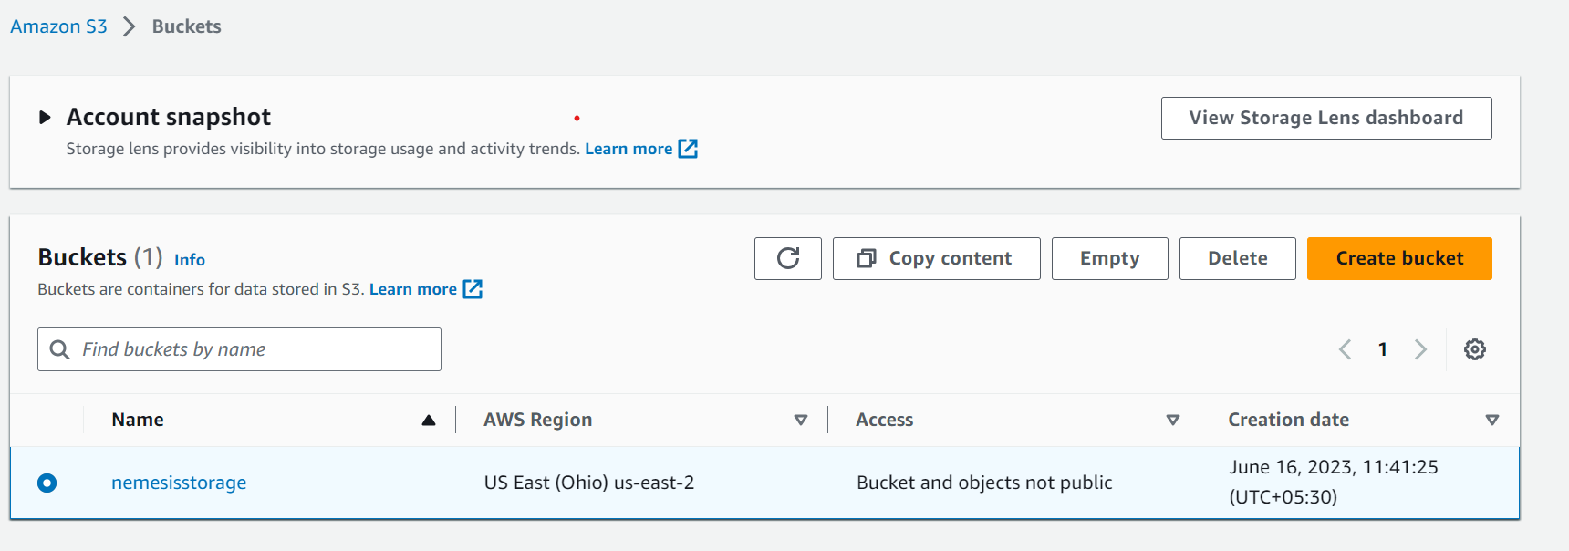

Fig: S3 Bucket

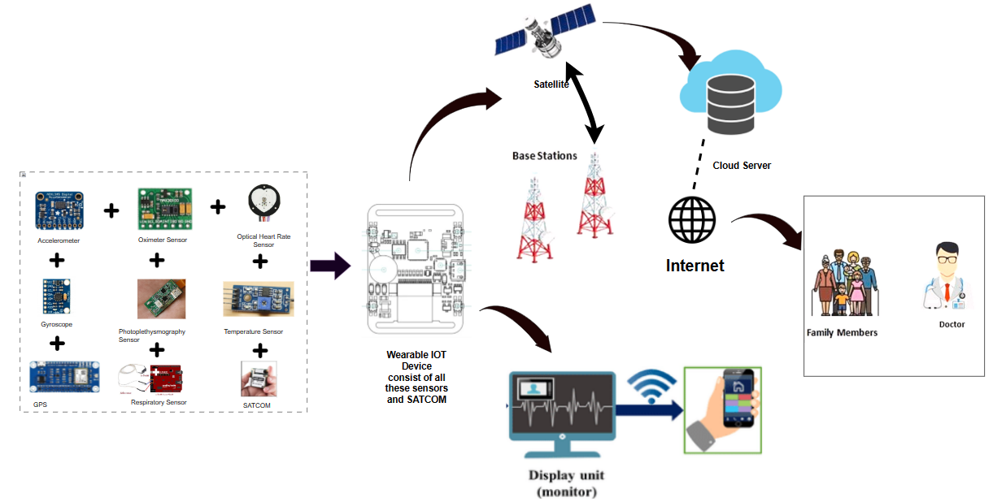

Fig: Sensors to Data Visualization

**2.7 Health Prediction System**

To utilize this data effectively, a website has been developed using HTML, CSS, JavaScript, and Python and hosted on a local server through Flask. The website provides a user interface for accessing the tracking and prediction system. Through the website, authorized personnel can monitor the real-time health data of person from smartwatch and receive prediction alerts in the event of a health risk by our machine learning model.

The system's continuous tracking capability, coupled with the ability to predict the risk through changes in sensor readings, ensures enhanced situational awareness and timely response for medical support.

**Flow Chart**

# CHAPTER-3 OVERALL DESCRIPTION

* 1. **Project Perspective**

The project involves designing, building, and deploying a comprehensive wearable IOT based Health Prediction System. This system integrates multiple components, including sensors (accelerometers, gyroscopes, oximeter, optical heart rate sensors), IoT devices, satellite communication (SATCOM), private cloud infrastructure, and a web-based user interface.

* 1. **User Characteristics**

It is known that the user operating the application is either the common man or the medical experts of health care industries. It is also expected that the user has basic implementation knowledge of the working and use of such systems.

* 1. **Project Functionality**

The system combines real-time tracking, risk prediction , data analysis, and user interface functionalities to enhance the situational awareness, response time, and early medical assistance providing facilities. It provides comprehensive monitoring, prediction and effective communication for timely assistance and support.

**Flow Chart**

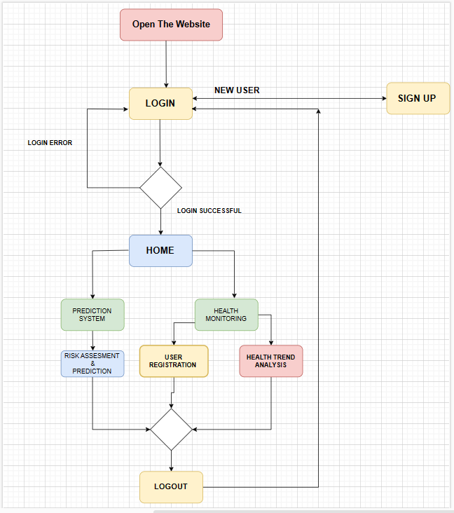

* 1. **System Walkthrough**
     1. **Client Side**

**3.4.1.1 Login Page**

A login page is a user interface component that allows users to authenticate themselves before accessing a system or application. It typically consists of input fields for username and password, along with a login button. Upon successful login, users gain access to the desired resources or functionalities.

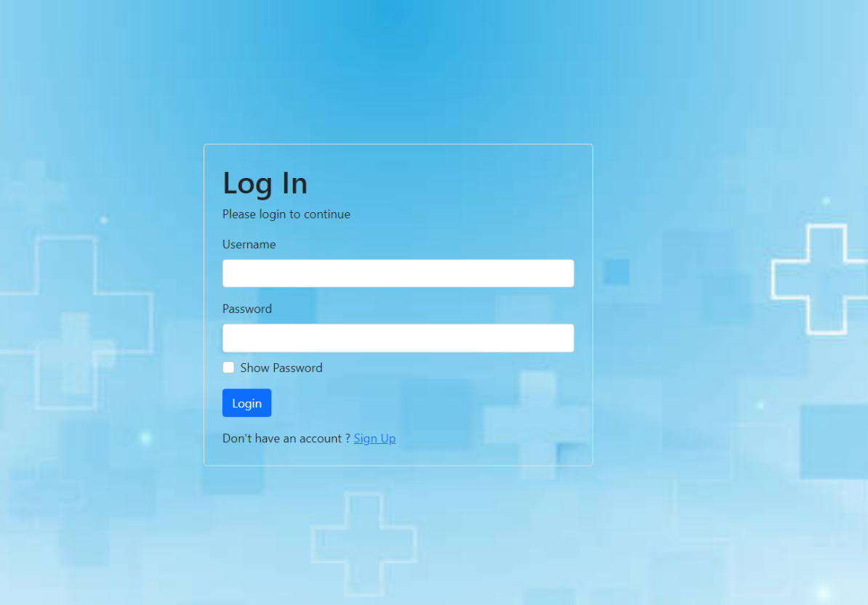

After successful login, opens dashboard;

**3.4.1.2 Dashboard**

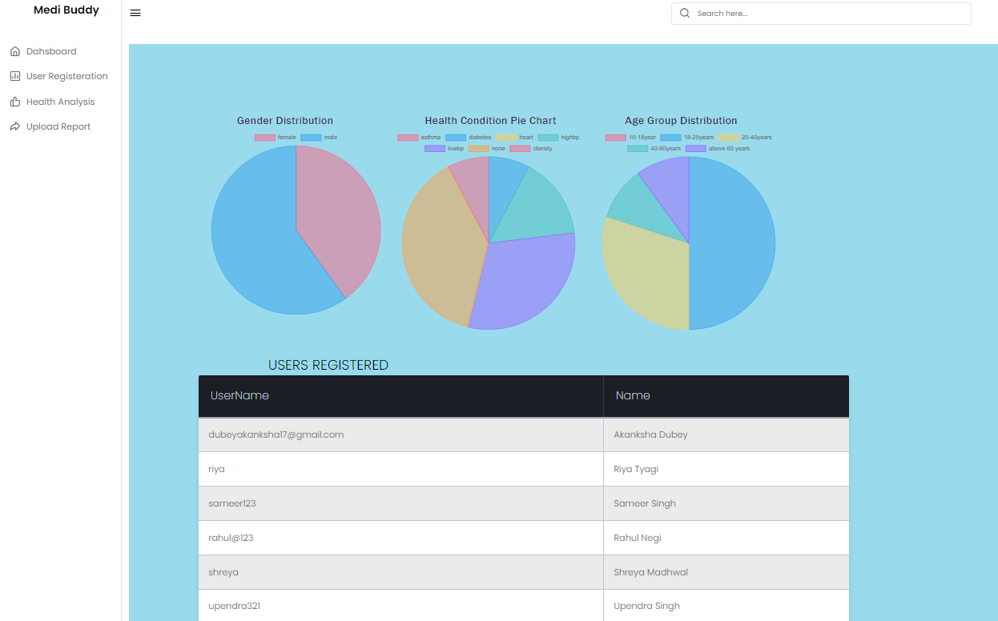

**3.4.1.3 User Registration Page**

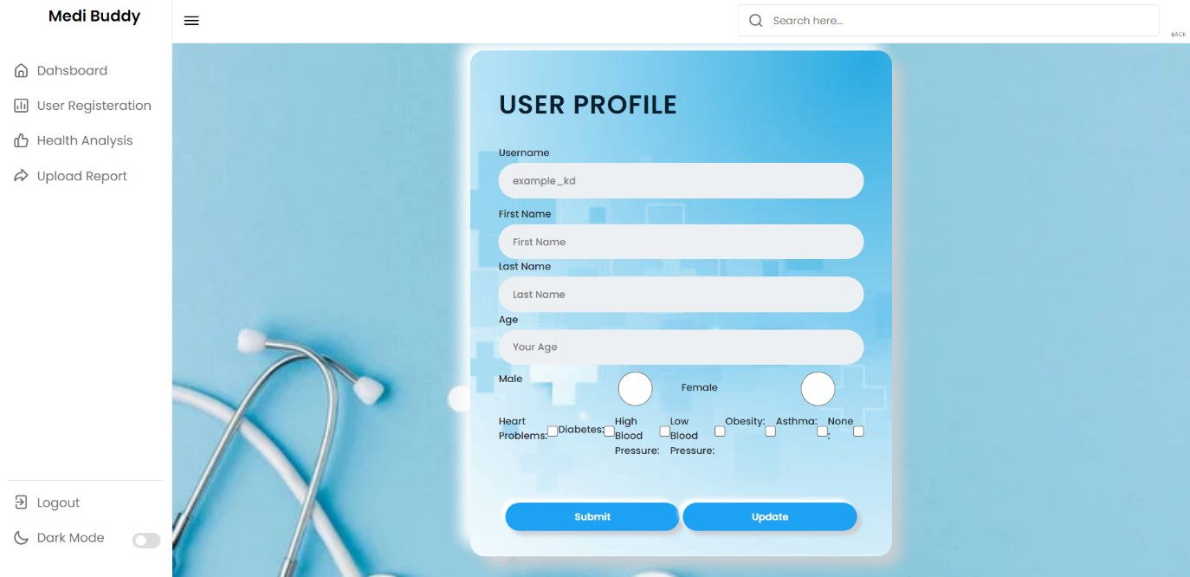

This page is used to register as new user providing his/her personal information such as name ,age and important health related history for keeping the track of health of a user.

**3.4.1.4 User Health Analysis**

This page provides two options one is health predictions based on National Early Warning Score that is used to predict the health of a person and provide warning or alert for medical assistance and another option provides the user with his/her health condition in past 30 days in graphical form . Below figure shows the UI of prediction system page.

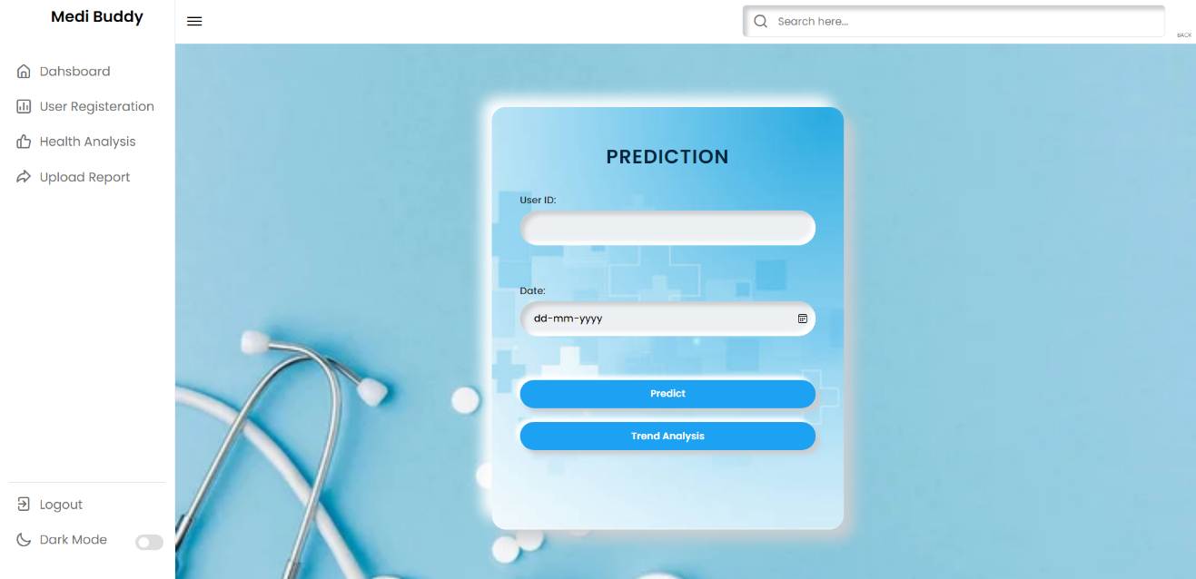

**3.4.1.4.1 Prediction Page**

When we click on predict button after entering the user id and the date of which you want to see the prediction. Below is the UI of the page loads that consist of user profile details and prediction results for individual parameter and final prediction result based on Nation Early Warning Score.

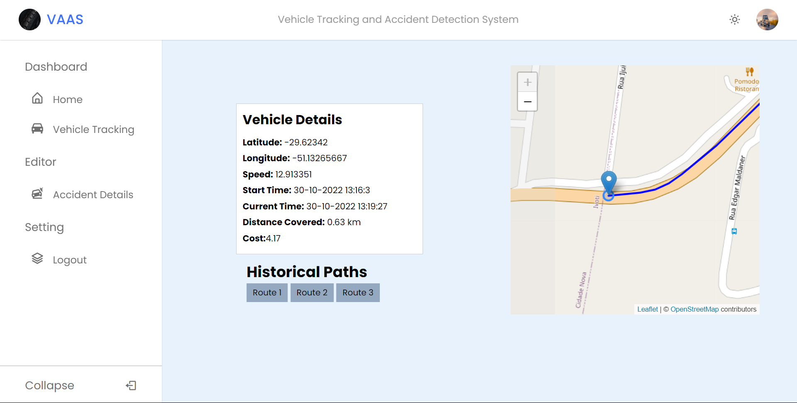

**3.4.1.4.2 Health Trends Analysis Page**

When we click on trend analysis button after entering the user id and the date of which you want to see the prediction. Below is the UI of the page loads that consist of line graph for each parameter i.e., heart rate,spo2,respiration rate, blood pressure and temperature of body in past 30 days.

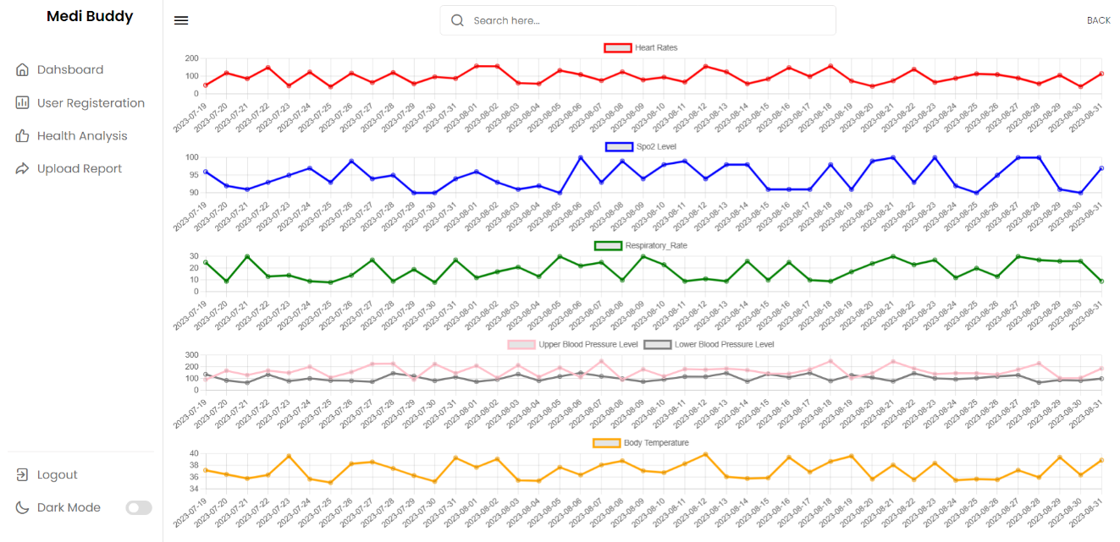

**3.4.1.5 Health Report Upload Page**

The user data in form of csv file can be uploaded through this page and that data will get stored in a table in a database that will be used in prediction and trend analysis. Below



* + 1. **Server Side**

1. **Login Page Backend**

The backend of a login page using **Flask** and **Sqlite3** involves the following steps:

* + - 1. Create a database in **Sqlite3** to store user information, with a table containing columns for username and password.
      2. Build an **HTML** login form that collects the username and password from the user.
      3. In the Flask backend:
         1. Retrieve the submitted username and password.
         2. Establish a connection to the sqlite3 database.
         3. Execute a query to retrieve the user's record based on the username.
         4. Verify the entered password against the stored password.
         5. If the authentication is successful, set a session variable to indicate the user's authenticated state.
         6. Redirect the user to a protected page upon successful login.
      4. Implement session management techniques to maintain the user's login state across multiple pages.
      5. Implement a logout mechanism that destroys the session and redirects the user to the login page.

1. **Health Prediction Model**

We will divide this part into several subparts:

1. **Data Preparation**

As of the time performing the writing this report, there is no available labelled dataset for this type of prediction models. The only choice is the synthetic dataset created thorough Python file.

Synthetic dataset consists of sensor readings from respiratory rate sensor, optical heart rate sensors, oximeter , Photoplethysmography sensors ,temperature sensor ,accelerometer and gyroscope in three different axes (X, Y, Z). The dataset includes three cases i.e., low risk , moderate risk and high risk based on National Early Warning Score.

Data label is generated based on National Early Warning Score for each parameter .These six simple physiological parameters form the basis of the scoring system. Below is the table of scoring system.

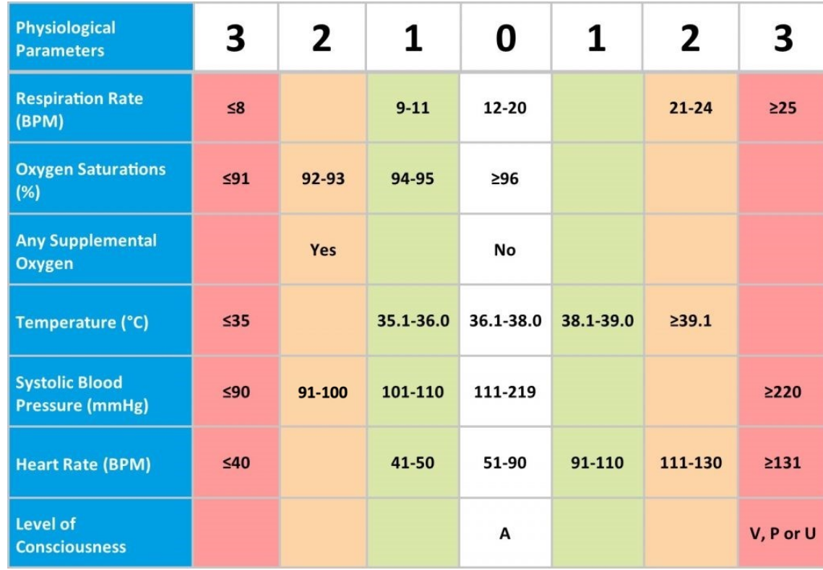

**The NEWS trigger system aligned to the scale of clinical risk.**

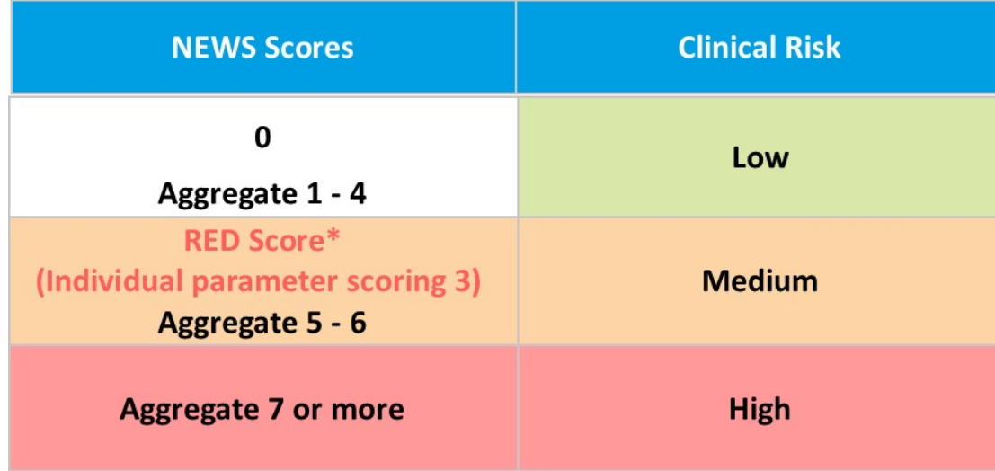

The dataset was labelled based on this NEWS Scores and clinical risk.

1. **Algorithm**

We have multiple classes namely low risk ,moderate and high risk for classification .

* + - * 1. **Sequential Neural Nets**

Sequential Neural Networks, also known as Recurrent Neural Networks (RNNs), are a type of artificial neural network designed to process sequential data. They are widely used for tasks such as natural language processing, speech recognition, and time series analysis.

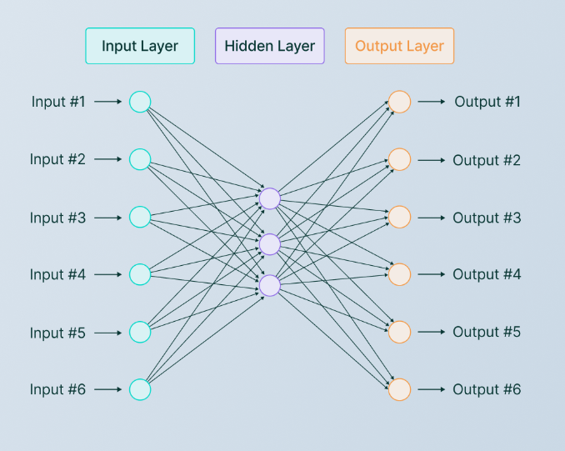

Fig: Structural Diagram of Sequential Neural Networks

- RNNs have a unique structure that allows them to retain and process information from previous steps in the sequence, making them suitable for tasks that involve analysing sequences of data.

- RNNs consist of recurrent connections between neurons, forming loops that enable the network to exhibit temporal behaviour.

- The ability to capture temporal dependencies makes RNNs effective for predicting accidents based on historical data, as they can learn patterns and correlations in the sequential data.

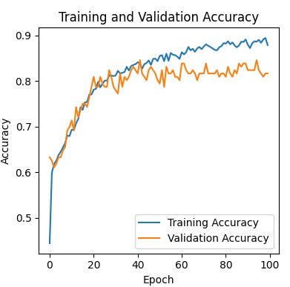

Fig: Accuracy vs Epoch for training and Validation Set

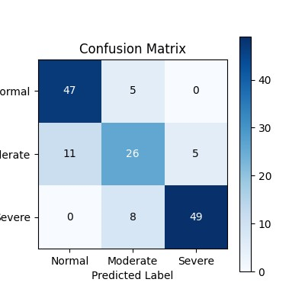

Fig: Confusion Matrix using Neural Network

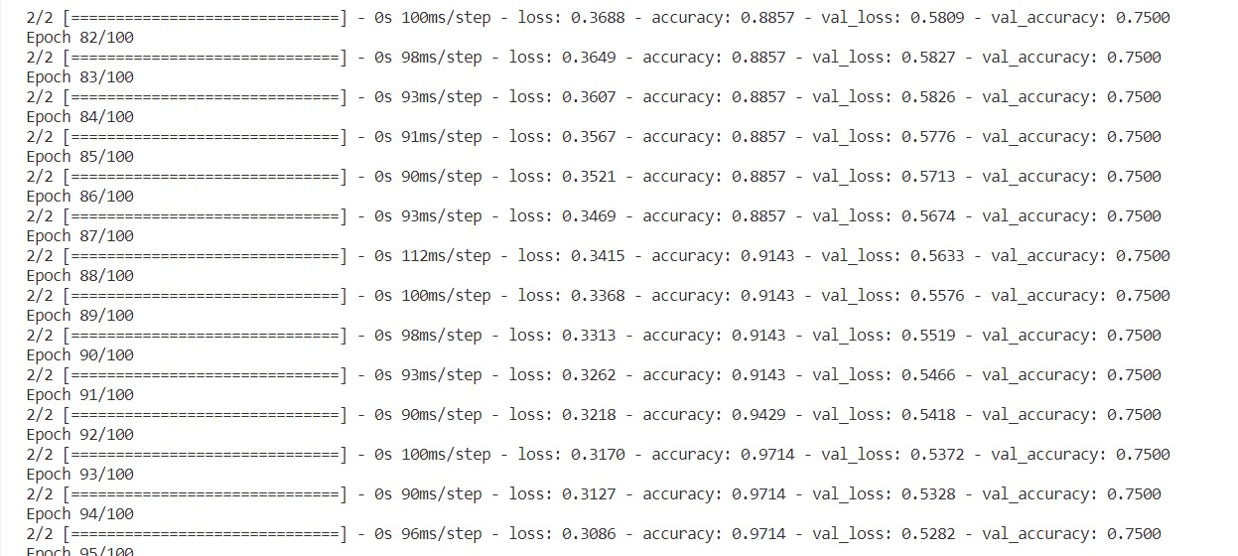

Fig: Epochs with metrics

* + - * 1. **XGBoost**

XGBoost (Extreme Gradient Boosting) is a powerful machine learning algorithm known for its efficiency and effectiveness in handling structured data. It belongs to the family of gradient boosting algorithms and is widely used for various regression and classification tasks.

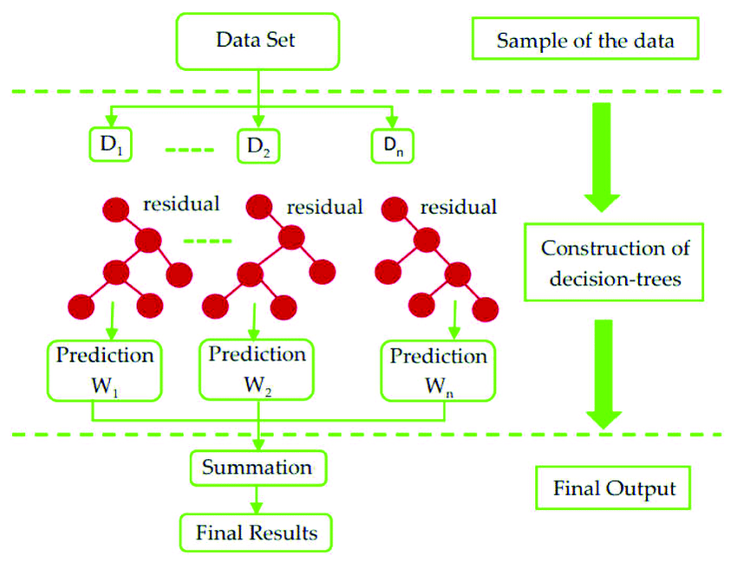

Fig: Structural Diagram of XGBoost

- XGBoost is an ensemble learning method that combines the predictions of multiple individual models called weak learners to create a stronger model.

- It utilizes a gradient boosting framework, which sequentially adds models to correct the mistakes made by previous models, thereby improving the overall prediction accuracy.

- XGBoost incorporates regularization techniques to prevent overfitting and provides options for fine-tuning hyperparameters to optimize the model's performance.

- It handles missing values, automatically handles feature selection, and provides feature importance analysis, making it suitable for predictive modelling tasks like accident prediction.

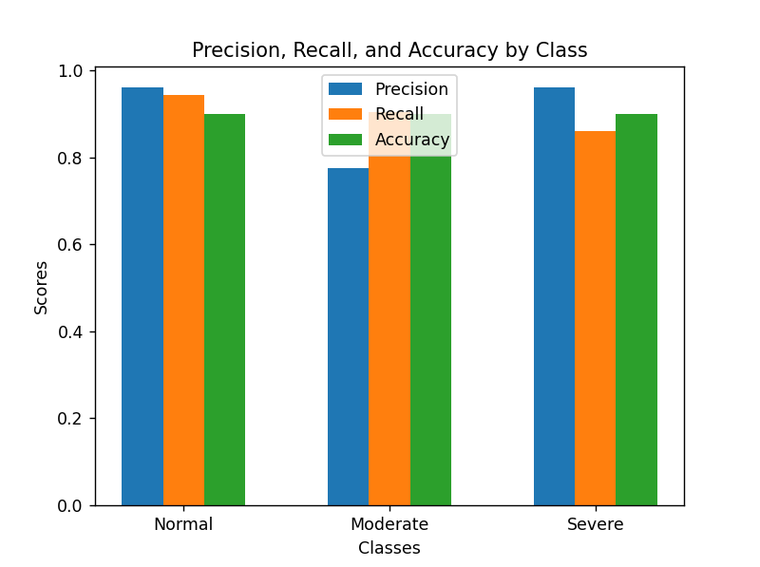

Fig: Scores vs Metrics (Accuracy, Recall, Precision)

Fig: Confusion Matrix

**Comparing Metrics among these two Algorithms**

|  |  |
| --- | --- |
| **Neural Nets** | **XGBoost** |
| Precision – 0.85  Recall – 0.91  F1-score – 0.88  Accuracy – 0.81 | Precision – .096  Recall – 0.86  F1-score – 0.91  Accuracy – 0.90 |

As we can see XGBoost have achieve the better accuracy and performance than neural networks there are a few reasons why XGBoost is preferred over neural networks:

1. **Interpretability**: XGBoost models provide more interpretability and explainability compared to neural networks. The feature importance analysis provided by XGBoost allows you to understand which features contribute the most to the prediction, making it easier to interpret the model's decision-making process. This can be important in domains where interpretability is a priority, such as finance or healthcare.

2. **Training Speed**: XGBoost generally has faster training times compared to neural networks, especially for large datasets. Neural networks often require a large amount of data and more complex optimization procedures, making them computationally expensive to train. XGBoost, on the other hand, can handle large-scale datasets efficiently and train models relatively quickly.

3. **Handling of Tabular Data**: XGBoost is well-suited for structured or tabular data, which is common in many binary classification problems. It can handle a wide range of features and perform automatic feature selection, handling missing values, and incorporating categorical variables. Neural networks, while powerful in handling sequential and unstructured data, may require additional preprocessing steps and more complex network architectures to effectively handle tabular data.

4. **Robustness to Noisy Data**: XGBoost is generally more robust to noisy or outlier data compared to neural networks. Neural networks can be sensitive to noisy input and may overfit or underperform if the data quality is compromised. XGBoost's gradient boosting framework and regularization techniques help mitigate the impact of noisy data, making it more resilient to such issues.

5. **Model Size and Deployment**: XGBoost models tend to have smaller model sizes compared to neural networks. This can be advantageous when it comes to model deployment, especially in resource-constrained environments such as mobile devices or embedded systems.

1. **HTML**

HTML, or Hypertext Markup Language, provides the foundation of web development. It’s the language used to create the basic structure of a web page organize the content on web page. HTML achieve this by using the system of tags that enclose the different elements of a webpage, defining their purpose. It offers semantic elements that convey the meaning of the content.

1. **CSS**

CSS or Cascading Style Sheets complements HTML by focusing on the presentation and visual aesthetics of web page .It allows developers to design the look of HTML elements. It is used to style the web page design.

1. **JavaScript**

JavaScript is the client-side scripting language for empowering the websites the dynamic and interactive behaviour. It response to user actions, manipulates the Document Object Model(DOM) of web pages, and facilitates asynchronous communication with web server.

1. **Flask**

Flask is a micro web framework for Python. It is used to build web applications, APIs, and other web-related software using the Python programming language. It provides the important components that are needed for web development such as routing, request handling and response generation. It is highly extensible that means we can add third party libraries for purpose like database integration, authentication. It includes a built-in sever, makes it easy to test and deploy your applications locally.

Below is the snippet to start the flask.

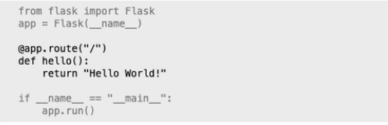

# CHAPTER-4 SYSTEM ANALYSIS

**4.1 Issue with the current system**

The current system has the following issues:

* The system is still in development phase.
* Various functionalities are yet to be implemented.
  + More accurate prediction system
  + Better Alert System
  + More practical dataset of sensors

**4.2 Feasibility Study**

Feasibility of a new system means ensuring that the new system, which we are going to implement, is efficient and affordable.

Feasibility is measured on three globally accepted scales, as follows-

1. Technical feasibility
2. Economic feasibility
3. Operational feasibility

4.2.1 TECHNICAL FEASIBILITY

Technical Feasibility involves financial considerations to accommodate technical enhancements. It is mainly concerned with the study of function, performance, and constraints that may affect the ability to achieve the system. The technical feasibility of this project depends on factors like IoT device, Satcom Connection, Virtual Cloud Formation, manager, and databases, etc. Since these factors are easily handled during maintenance, the project is said to be technically feasible.

4.2.2 ECONOMIC FEASIBILITY:

Economic feasibility is concerned with comparing the development cost with the income/benefit derived from the developed system. Economic Feasibility is mainly concerned with the cost incurred in the implementation of the software. Since this project is developed using freely available software, hence this project has good economic feasibility.

4.2.3 OPERATIONAL FEASIBILITY:

People are inherently instant to change and computers have been known to facilitate change. An estimate should be made to how strong a reaction the users are likely to have towards the development of such a system. The graphical interface of the system is simple and the application is very user friendly for a person with basic knowledge of computer to handle it. The user is accustomed to computerized systems. Hence, this system is operationally feasible too.

**4.3 SYSTEM REQUIREMENT**

As already stated, the system is extremely lightweight and feasible. Hence, the requirements for deployment of this server are extremely minimum and easily manageable.

4.3.1 Hardware Specifications:

* Processor: Intel i5 or higher/ Equivalent
* Hard Disk: 8 GB or higher
* RAM: 64 MB or higher

4.3.2 Software Specifications:

* Operating System: Windows 7 or above
* Application Server: Apache or Equivalent
* Flask Server

# CHAPTER-5 TOOLS AND TECHNOLOGIES

**5.1 Python**

Python is a versatile and high-level programming language known for its simplicity and readability. It was created by Guido van Rossum and released in 1991. Here are some key points to understand Python:

1.General-Purpose Language: Python is a general-purpose programming language, meaning it can be used for a wide range of applications. It supports various programming paradigms, including procedural, object-oriented, and functional programming.

2. Cross-Platform Compatibility: Python is a cross-platform language, meaning it can run on different operating systems such as Windows, macOS, and Linux without requiring modifications to the code. This portability makes it convenient for developing applications that can run on multiple platforms.

3. Rich Standard Library and Third-Party Packages: Python comes with a vast standard library that provides many pre-built modules and functions for common tasks, making it efficient and productive. Additionally, Python has a vast ecosystem of third-party packages and libraries available through the Python Package Index (PyPI), which extend its functionality for various domains and purposes.

4. Integration and Extensibility: Python can be easily integrated with other languages like C, C++, and Java, allowing developers to leverage existing codebases or use performance-critical components. It provides interfaces to many external libraries and frameworks, making it flexible and extensible.

5. Used in Various Domains: Python is widely used in various domains, including web development, data analysis, machine learning, artificial intelligence, scientific computing, automation, scripting, and more. Its versatility and extensive libraries make it suitable for a wide range of applications.

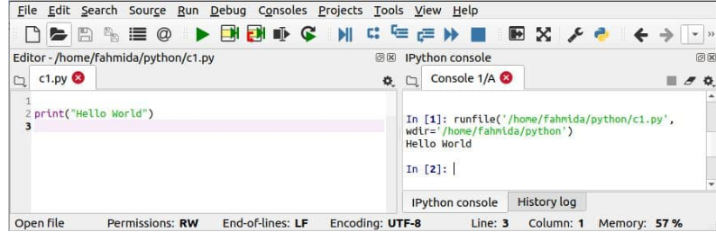

**5.2 Visual Studio Code**

Visual Studio Code (VS Code) is a lightweight and versatile source code editor developed by Microsoft. Here are some key points to understand VS Code:

* 1. **Cross-Platform Compatibility**: VS Code is compatible with major operating systems such as Windows, macOS, and Linux, allowing developers to use it on their preferred platform.
  2. **Feature-Rich Editor**: Despite its lightweight nature, VS Code provides a wide range of features to enhance the coding experience. It supports syntax highlighting, code completion, code navigation, debugging, version control integration, and more.
  3. **Extensions Ecosystem**: VS Code has a rich extensions ecosystem that allows developers to customize and extend its functionality. There are numerous extensions available for different programming languages, frameworks, and development tools, enabling developers to tailor their environment to their specific needs.
  4. **Customizable Interface**: VS Code offers a customizable user interface, allowing developers to personalize the editor according to their preferences. They can choose different themes, layouts, and keyboard shortcuts, making their coding environment more comfortable and visually appealing.
  5. **Integrated Terminal**: VS Code includes an integrated terminal that allows developers to run commands, build applications, and perform various tasks without leaving the editor. This helps streamline the development workflow by keeping everything in one place.
  6. **IntelliSense:** VS Code provides intelligent code suggestions and auto-completion based on the context of the code. This feature helps developers write code faster and with fewer errors by offering suggestions for functions, variables, and code snippets.
  7. **Live Share Collaboration**: VS Code includes a Live Share feature that enables real-time collaboration between developers. They can share their workspace with others, allowing them to edit and debug code together, which is especially useful for remote pair programming or team collaboration.
  8. **Free and Open Source**: VS Code is free to download and use, and it is released under an open-source license. This means that developers can contribute to its development, report issues, and even customize the editor's source code.

Fig. Snippet of Visual Studio Code Editor

# CHAPTER-6 CONCLUSION AND FUTURE WORK

**6.1 Conclusion**

The development of Wearable IOT based Health Prediction System is complete in partial fulfilment of the requirements health tracking and risk prediction generation website with GUI. This tool can predict the risk and generate alert for that. This tool can also track multiple user health in real-time using sensory data from smartwatch.

**6.2 Future Work**

In future, there is a huge scope of addition of features. Following features have been planned and are ready to be worked upon very soon:

1. Generating dataset for better Prediction

2. Adding more parameters for health analysis.

3. Developing a personalised chatbot for health assistance.

4. Deploying Tool for real-time usage.

5.Adding more features in prediction model for better accuracy.

These features will strength the tool as a complete application software. Once completed, they will be integrated to existing application.

# REFERENCES

1**.** [Accelerometer Data Set | Kaggle](https://www.kaggle.com/datasets/dhinaharp/accelerometer-data-set)

2. [MotionSense Dataset : Smartphone Sensor Data - HAR | Kaggle](https://www.kaggle.com/datasets/malekzadeh/motionsense-dataset)

3. [(PDF) Human activity recognition from smart watch sensor data using a hybrid of principal component analysis and random forest algorithm (researchgate.net)](https://www.researchgate.net/publication/329263557_Human_activity_recognition_from_smart_watch_sensor_data_using_a_hybrid_of_principal_component_analysis_and_random_forest_algorithm#:~:text=The%20data%20are%20obtained%20from,been%20created%20for%20each%20class.)

4. [Cloud Computing Services - Amazon Web Services (AWS)](https://aws.amazon.com/)

5. [National Early Warning Score (NEWS) as Prognostic Triage Tool for Septic Patients - PMC (nih.gov)](https://www.ncbi.nlm.nih.gov/pmc/articles/PMC7602891/#:~:text=It%20includes%20seven%20parameters%20(temperature,score%20(NEWS%E2%89%A57).)

6. [Stock Images, Royalty-Free Pictures, Illustrations & Videos - iStock (istockphoto.com)](https://www.istockphoto.com/)

**7.** [Freepik: Download Free Videos, Vectors, Photos, and PSD](https://www.freepik.com/)

8. [The technology | National Early Warning Score systems that alert to deteriorating adult patients in hospital | Advice | NICE](https://www.nice.org.uk/advice/mib205/chapter/The-technology#:~:text=Resource%20consequences-,The%20technology,sepsis%2C%20in%20hospitals%20in%20England.)

9. [Heart Disease Dataset | Kaggle](https://www.kaggle.com/datasets/johnsmith88/heart-disease-dataset)

10 [Explained: Five main sensors on smartwatches and what they do - Times of India (indiatimes.com)](https://timesofindia.indiatimes.com/gadgets-news/explained-five-main-sensors-on-smartwatches-and-what-they-do/articleshow/97131602.cms)

11. [Diabetes Prediction Using Machine Learning - Analytics Vidhya](https://www.analyticsvidhya.com/blog/2022/01/diabetes-prediction-using-machine-learning/)

12. [diabetes.csv | Kaggle](https://www.kaggle.com/datasets/saurabh00007/diabetescsv)

13. [Respiratory Rate Estimation by peterhcharlton](https://peterhcharlton.github.io/RRest/datasets.html)

14. [In Hospital Mortality Prediction | Kaggle](https://www.kaggle.com/datasets/saurabhshahane/in-hospital-mortality-prediction)

15. [Google Images](https://www.google.co.in/imghp)

16. [ResearchGate | Find and share research](https://www.researchgate.net/)

17. [IEEE Xplore](https://ieeexplore.ieee.org/Xplore/home.jsp)